CONNECTED, LEVEL 2 2013, I Spy …  What Alice Saw  by Don Long  Overview  In this article, students read about Alice McKenzie and her observations of a bird she saw in Martins Bay. Alice later finds out that the bird she observed wasn’t what she thought it was.  A Google Slides version of this article is available at www.connected.tki.org.nz. |  |  |  |  | 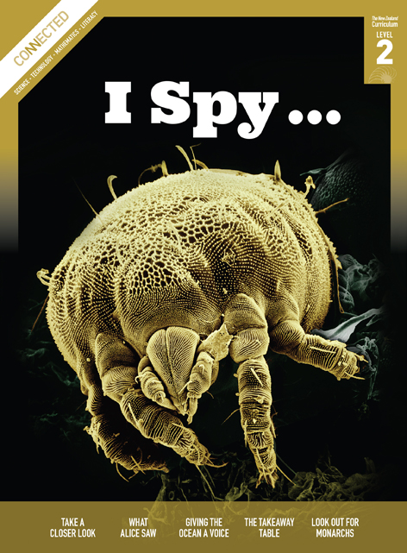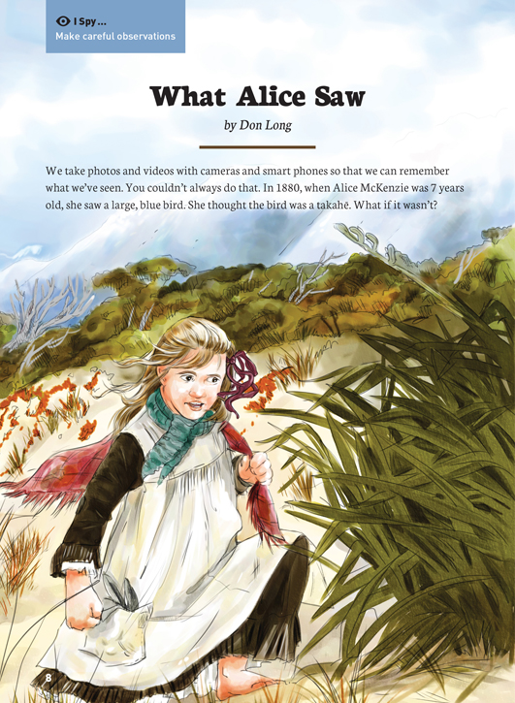
Science capability  Students need to develop a set of capabilities that support them to ask informed questions if they are to participate as “critical, informed, responsible citizens in a society in which science plays a significant role”. The capabilities enable students to meet the achievement objectives in a way that supports the purpose of science in The New Zealand Curriculum and the development of the key competencies. These capabilities include being ready, willing, and able to gather and interpret data. Students need to understand what counts as evidence in science, the importance of observation, and the difference between observation and inference. |  |  |  | Text characteristics  - Scientific and technological vocabulary and Māori nouns, the meanings of which are supported by illustrations and written explanations  - Photographs and diagrams that clarify the text and require some interpretation  - A mixture of text types, including direct quotation  - A clearly structured article with headings that signify the information in each section and help the reader to navigate the text.

Curriculum context

SCIENCE
NATURE OF SCIENCE: Understanding about science  Achievement objective(s)  L2: Students will appreciate that scientists ask questions about our world that lead to investigations and that open-mindedness is important because there may be more than one explanation. |  | NATURE OF SCIENCE: Evolution  Achievement objective(s)  L2: Students will explain how we know that some living things from the past are now extinct. |  |  |  |  | Key Nature of Science ideas  - Science knowledge is based on direct, or indirect, observations of the natural physical world.  - Scientists gather data using their senses to make observations.  - Making careful observations often involves measuring something.  - Observations are influenced by what you already know.  Key science ideas  - Anatomical and behavioural characteristics are important in animal classification. Such features are used because they are often easy to identify.  - Differences and similarities in external characteristics are used to distinguish between living things.

ENGLISH
READING  Ideas  L2: Students will show some understanding of ideas within, across, and beyond texts. |  | INDICATORS  - Uses their personal experience and world and literacy knowledge to make meaning from texts.  - Makes meaning of increasingly complex texts by identifying main ideas.  - Makes and supports inferences from texts with some independence. |  |  |  | THE LITERACY LEARNING PROGRESSIONS  The literacy knowledge and skills that students need to draw on by the end of year 4 are described in The Literacy Learning Progressions.

Scientific investigation
A science investigation where you change or try something and observe what happens is called an experiment. Not all scientific investigations are experiments; there are many ways of investigating in science. The New Zealand Curriculum science achievement aims indicate that students should experience a range of approaches to scientific investigation including classifying and identifying, pattern seeking, exploring, investigating models, fair testing, making things, and developing systems. Many scientific investigations involve systematic observation over time of an object, an event, a living thing, or a place.  Some important things to remember when you do a scientific investigation are: to be systematic and fair; to make sure that only one thing is changed at a time if you are doing an experiment or fair test so you are sure which changes result in which outcome; to observe and record what happens very carefully; and to be open minded so you notice things you are not expecting. |  |  |  | Sound data is obtained when you are able to get similar outcomes each time you do the same thing, or when data has been collected in the same way and in a systematic manner. No investigation or experiment results in a “wrong” outcome. You may have done something differently from others or the conditions may be slightly different so you don’t get the same result as others do, but it is not “wrong”.  Thinking about and developing explanations about why things happen the way they do, based on evidence, is an important aspect of science. Another important aspect is critically evaluating methods and ideas. Part of a scientist’s work is critiquing and evaluating the methods and ideas of other scientists. They expect their work to be subject to critique. If they are going to be able to make informed decisions about scientific issues as responsible citizens, students first need to experience a range of approaches to scientific investigation and to practise critique and evaluation of scientific methods and ideas – both their own and those of others – just like scientists do!

Meeting the literacy challenges

The following strategies will support students to understand, respond to, and think critically about the information and ideas in the text. After reading the text, support students to explore the key science and technology ideas outlined in the following pages.  TEXT CHARACTERISTICS  - Scientific and technological vocabulary and Māori nouns, the meanings of which are supported by illustrations and written explanations  - Photographs and diagrams that clarify the text and require some interpretation  - A mixture of text types, including direct quotation  - A clearly structured article, with headings that signify the information in each section and help the reader to navigate the text. |  | TEACHER SUPPORT  Want to know more about instructional strategies? Go to:  http://literacyonline.tki.org.nz/Literacy-Online/Teacher-needs/Pedagogy/Reading#Years1-4  http://literacyonline.tki.org.nz/Literacy-Online/Teacher-needs/Pedagogy/Reading#Years5-8  http://literacyonline.tki.org.nz/Literacy-Online/Student-needs/National-Standards-Reading-and-Writing  http://www.literacyprogressions.tki.org.nz/  “Working with Comprehension Strategies” (Chapter 5) from Teaching Reading Comprehension (Davis, 2007) gives comprehensive guidance for explicit strategy instruction in years 4–8.  Teaching Reading Comprehension Strategies: A Practical Classroom Guide (Cameron, 2009) provides information, resources, and tools for comprehension strategy instruction.

INSTRUCTIONAL STRATEGIES
FINDING INFORMATION IN THE TEXT  DISCUSS the title, providing the opportunity for students to think about the author’s purpose for writing, and make predictions.  - Why do you think that this story is called, “What Alice Saw”?  ASK QUESTIONS to support the students to make connections to their prior knowledge and to ask their own questions and make predictions.  - What do you know about takahē?” What would be so special about seeing a takahē?  - What else could this bird be? What information might you need or questions might you ask to make a decision?  - What questions would you ask Alice, if you could, to identify the bird she first saw?  EXPLAIN that the students will need to infer some details.  - I wonder how tall the bird was? I know it was bigger than a pūkeko but smaller than a takahē. I’ve never seen a takahē but I’ve seen lots of pūkeko so maybe about this [indicating with gesture] high?  Ask the students to SCAN page 11 and IDENTIFY the main message.  - How do we know that this is the main idea? (The heading and quote.) What is the inference that Alice draws? (Ask the students to put this into a simple “If … then …” statement.)  The text finishes with a question to the reader.  - What do you think? Justify your answer with evidence from the text. |  | DEALING WITH UNFAMILIAR VOCABULARY AND USING THE DIAGRAMS TO CLARIFY TEXT  EXPLAIN to the students that many words in this text may be unfamiliar to them. Point out that some of these words are explained in the glossary and some are explained in the text. The map and diagrams also help to clarify key information.  Look at the maps with the students, read the map labels, and DISCUSS how they help to explain the text.  - What do you think the word “remote” means? How does the map support readers to understand just how remote Martins Bay is?  Read Alice’s recount and the following paragraph. Support the students to locate information and make a decision and justify it.  - Looking at the maps, identify where Alice was when she saw the bird.  - What does Alice record in her observations? Are they useful observations to work out what the bird was? Why or why not?  Ask the students whether they have noticed something interesting about the bird names. Draw out the fact that each bird has at least two different names. One is a scientific name and one is the name by which they are usually known in New Zealand. Explain that scientists use scientific names to make sense of the world’s animals and plants. Most of these words come from the Latin language. Scientists all around the world use the same set of words so that they don’t get confused when different people have different names for the same animal or plant. Have the students compile a list of the names for each bird.

Teacher support
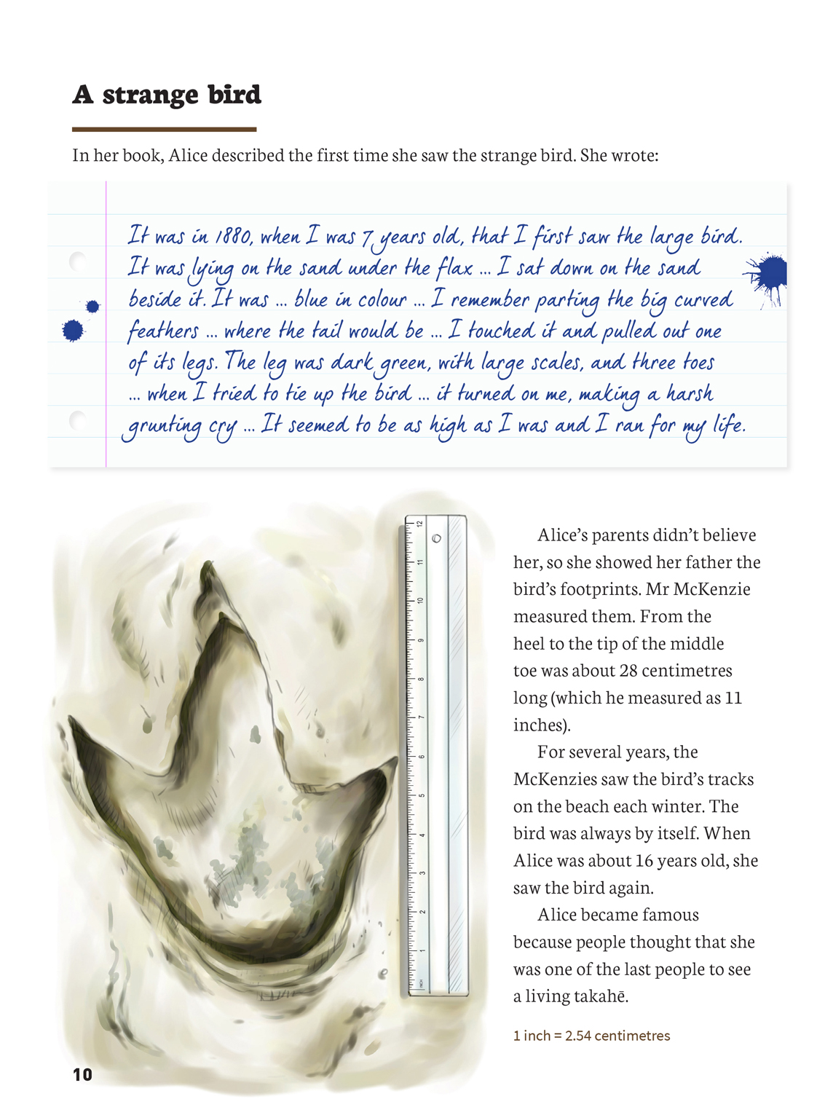 | Many things that lived in the past are now extinct.  Making observations over time is one way scientists find out more about the world.  Making careful observations often involves measuring something.  Scientists gather data using their senses to make observations.
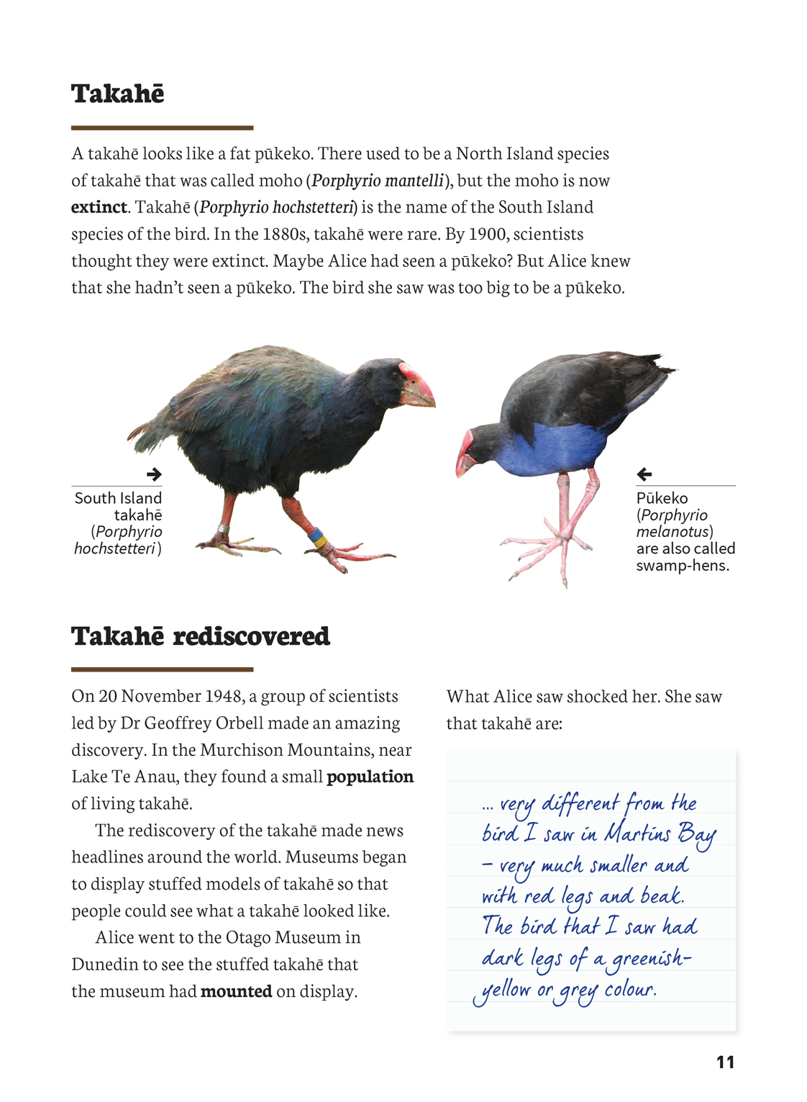 | Anatomical and behavioural characteristics are important in animal classification. These features are used because they are easy to identify.  Differences and similarities in external characteristics are used to distinguish between living things.  Scientists are open-minded, because there may be more than one explanation.

Exploring the science
Some activities focus directly on the science capability of “gathering and interpreting data” and the Nature of Science strand. Other activities extend student content knowledge. You are encouraged to adapt these activities to make the focus on Nature of Science explicit and to support students to develop the capability to collect and interpret data.
LEARNING FOCUS |  | KEY SCIENCE IDEAS
Students make observations, gather data, and interpret and discuss outcomes based on their observations. |  | Key Nature of Science ideas  - Science knowledge is based on direct, or indirect, observations of the natural physical world.  - Scientists gather data using their senses to make observations.  - Making careful observations often involves measuring something.  - Observations are influenced by what you already know.  Key science ideas  - Anatomical and behavioural characteristics are important in animal classification. Such features are used because they are often easy to identify.  - Differences and similarities in external characteristics are used to distinguish between living things.

LEARNING ACTIVITIES

Activity 1: Classifying the bird Alice saw
Explain that scientists have many ways of grouping animals. Anatomical and behavioural characteristics are important in animal classification. Anatomical characteristics relate to how a bird looks and behavioural characteristics to how a bird acts. These features are used because they are often easy to identify. DNA analysis is also important.
Ask the students to re-read the text and use a chart like the one below to record the characteristics of the bird Alice described.
Anatomical characteristics | Behavioural characteristics
Large | Lay on the sand under a flax
Go to Replay Radio and play the recording of Alice talking about seeing and touching the bird in 1880. Ask the students to take notes as they listen, recording any new information they learn about what the bird looked like and how it behaved.
Can you imagine what the bird looked like?
Have the students use the information they have collated to draw the bird in its habitat. Have the students compare their drawings to the drawing on page 12 in Connected. Does the illustration reflect Alice’s observations?
The key resource for this activity is an interview in which Alice McKenzie describes seeing a moa in her childhood. Recorded in Dunedin in 1959, it is available from Sound Archives Ngā Taonga Kōrero, ID 246952.

Activity 2: Comparing and contrasting data
Provide Venn diagrams that the students can use to record the similarities and differences between the rediscovered takahē and bush moa and the takahē and pūkeko. They can use their list of the characteristics of a bush moa as a starting point.
Takahē
Bush moa

How were they the same? How were they different?
As part of this exercise, the students could find out more about all three birds using print and digital resources.

Extension activity
The students could:
carry out their own formal observations of birds – at school or at home, in a sanctuary or wildlife reserve, online, or by viewing stuffed birds in a museum
record their own “encounter” with a bird in a diary entry like Alice’s
use a Venn diagram to compare observations of two similar birds, for example, blackbird and tūī. What details are necessary to tell the difference between them?

Activity 3: Scaling up
Support the students to use their knowledge of scale to conduct a drawing exercise where they use what they know of different birds’ shapes and sizes to draw the footprint of the bush moa to the scale described.
How big might the rest of the bird have been given the size of its footprint? Can you determine the size and shape of a bird’s body by the size and shape of its footprint?
Students may need to research and gather information on bird and claw sizes for this activity.

Extension activity
Using information from the students’ own estimates (based on their observations and other information sources), have the students complete height, body-length, and foot-length charts for a range of birds beginning with pūkeko, takahē, and moa and then adding birds they have observed – and finally, other native birds they find out information about. They could draw “to scale” or actual-size pictures to put on the charts.
Encourage the students to ask questions of the data they have collected.
I wonder whether there is a relationship between height or body length and foot length. I wonder why long feet might be more useful for some birds. Where do the birds with the longest feet live? What might make it difficult for a tall bird to survive?

Activity 4: Thinking like a scientist
Discuss why Alice initially thought the bird was a takahē and why she changed her mind. Invite the students to share other examples they know about when scientists initially thought one thing was true, only to be confronted with evidence that meant they had to change their minds.
Do you have a personal experience where your initial interpretation or prior knowledge/understanding of a process or object were challenged when you were confronted by new data?
What does this tell you about how a scientist needs to think about evidence?

Activity 5: Test your powers of observation
In small groups, get the students to take turns describing common objects while the others try to recognise what is being described.

Google Slides version of “What Alice Saw” www.connected.tki.org.nz

RESOURCE LINKS

Making Better Sense of the Living World – “Birds” (pages 46–51)
Building Science Concepts, Book 3 – Birds: Structure, Function, and Adaptation
Moa: The Life and Death of New Zealand’s Legendary Bird (Craig Potton Publishing, 2012)
Science Online www.scienceonline.tki.org.nz
Assessment Resource Banks http://arb.nzcer.org.nz/ (LW0647 – diagram of a moa)
Learnz http://www.learnz.org.nz (Takahē, Kiwi Conservation)
Alice McKenzie describing what she saw: www.radionz.co.nz/audio/player/2549378 Recorded in Dunedin in 1959, available from Sound Archives Ngā Taonga Kōrero, ID 246952.
New Zealand Birds Online http://nzbirdsonline.org.nz/species/little-bush-moa

